

Microsoft Dynamics® GP

Using Application Virtualization with
Microsoft Dynamics® GP 2010

White Paper

July, 2011

Contents
Introduction 3
Audience 3
Prerequisites 3
Compatibility 3
Overview 4
App-V Overview 4
Using App-V to deploy Microsoft Dynamics GP 4
Recommendations before sequencing 5
Use a dedicated sequencing machine: 5
Office integration 5
Create an initial ODBC connection 6
Tips and tricks: 6
Sequencing the Microsoft Dynamics GP Client 7
Sequencing the baseline GP Client 7
Publishing the sequenced Microsoft Dynamics GP Client 19
Deploying the packaged files 19
Configure App-V server 20
Execute the sequenced Microsoft Dynamics GP Client 24
On End-user Desktop 24
On Remote Desktop Services 25
Updating the sequenced client 26
References 29

Introduction
Welcome to the “Using Microsoft Application Virtualization(App-V) with Microsoft Dynamics® GP 2010” white paper. This guide is intended to help an administrator deploy the Microsoft Dynamics GP client using App-V technology.

Audience
This document is intended primarily for Microsoft Dynamics GP administrators who need to simplify and centrally manage the deployment of the Microsoft Dynamics GP client application.

These instructions are compatible with a deployment of Microsoft Dynamics GP on user workstations as well as on Microsoft Remote Desktop Services (formerly known as Terminal Services). They also apply for both on-premise and hosted deployments.

Prerequisites

Prior knowledge of the following technologies is recommended to fully understand the instructions
- Microsoft Dynamics GP 2010 (R2)
- Microsoft Windows Server 2008 (R2)

Compatibility
These instructions apply to Microsoft Dynamics GP 2010 and Microsoft App-V 4.6 SP1.

Overview

App-V Overview
Today’s business desktop is awash in applications. Each installed application requires lengthy regression testing and deployment processes before it reaches production. Because applications are only available where they are installed, users are tied to their computers. This makes complex yet critical projects such as operating system and application migrations, security refreshes, and disaster recovery plans harder to complete.

Microsoft Application Virtualization (App-V) changes the current approach to application deployment and management by transforming applications into virtualized, network-available services. These services are never installed, never conflict, and minimize costly compatibility testing. Users and their application environments are no longer machine-specific, and the machines themselves are no longer user-specific. This can enable IT professionals to be much more flexible and responsive to business needs, and dramatically reduce the cost of desktop management initiatives.

App-V employs an innovative system for centrally deploying applications. Rather than "pushing" down and installing entire applications, the first time end users request an application, the App-V client only "pulls" the code necessary to start the program from a central Virtual Application Server. This is typically 20 to 40 percent of the total application.

After the initial launch the application and user preferences are saved in a file-based cache location on the client machine. Subsequent application launches are loaded from this local cache, resulting in faster launches with little impact on network bandwidth. This ensures that the user’s applications are also preserved, even in the case of unexpected computer shutdown.

The core of App-V's management is the App-V Management Web Service, which provides a central service for administering App-V servers and applications. Administrators communicate with the Management Web Service via the App-V Management Console. Using this console, you can publish and remove applications, control server settings, configure metering, and more.

Using App-V to deploy Microsoft Dynamics GP

This document describes how to leverage the App-V technology for Microsoft Dynamics GP 2010. Currently, App-V focuses on desktop applications so the scope of this document is the Microsoft Dynamics GP client.

It is assumed you have access to App-V software which is part of the Microsoft Desktop Optimization Pack and Microsoft Application Virtualization for Terminal Services, and available via MSDN®.

The diagram below shows the 3 main steps to enable the App-V technology:

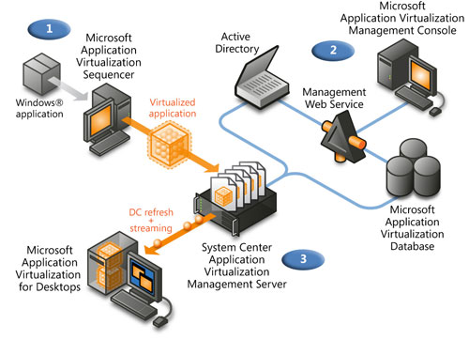

Step 1 is to sequence the application. This means installing the application in the App-V virtual environment so it becomes portable.
Step 2 is to centrally deploy the image so it can be available to the client systems.
Step 3 is to stream the image to the end user client system for execution.

Recommendations before sequencing

Use a dedicated sequencing machine:

We recommend using a blank virtual machine (using Virtual PC or Hyper-V for instance) image the machine with Windows 7 (or your target operating system) to make sure all prerequisites will be installed as part of the sequencing process. It is a good idea to make a snapshot on the system before you start sequencing to allow you to easily get back to the baseline if you need to repeat the sequencing process.

Office integration
We recommend that you install Microsoft Office on the sequencing machine before sequencing Microsoft Dynamics GP. This is to make sure that registry information about Microsoft Office is available during the Microsoft Dynamics GP installation. The result of not pre-installing Microsoft Office could result in some Office integrations not working in Microsoft Dynamics GP and requiring you to re-sequence Microsoft Dynamics GP. Also, be sure that Microsoft Office is installed on the target machines. Note that we have not tested the scenario where both Microsoft Dynamics GP and Microsoft Office are delivered via App-V.

We also recommend installing the Microsoft Office Web Components as well as any Microsoft Office related plug-in (including the Open XML SDK 2.0 for Microsoft Office plug-in that is a Microsoft Dynamics GP prerequisite component) on the sequencing machine. It is also assumed that these will be installed on the target machines as well.

Create an initial ODBC connection

If an Open Database Connectivity (ODBC) DSN setting does not exist on the base sequencing machine image and the application being packaged creates one, the entire registry key associated with ODBC settings will become virtualized. This will prohibit the packaged application from seeing any ODBC DSN settings that exist on the base client machine. If an ODBC entry already exists on the Sequencer machine, only the ODBC settings will become virtualized, and the ODBC settings on the Client will be merged with the ODBC settings in the package.

If an ODBC entry doesn’t already exist on the sequencer image, then navigate to Control Panel >, administrative tools >, open DataSource (ODBC), and create a new default User DSN:

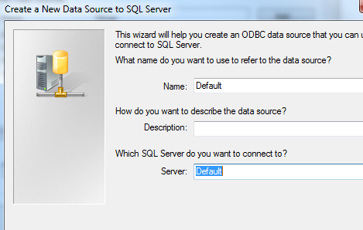

Tips and tricks:
- Make sure the sequencing machine has access to the Microsoft SQL Server® where the Microsoft Dynamics GP databases are installed. This is because during the install process, you will need to run Microsoft Dynamics GP Utilities to finalize the installation.

- You may get a warning message about running processes when you start the sequencer. For instance, the following processes might be running by default on a Windows 7 machine

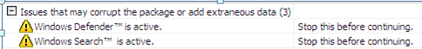

Stop any processes listed before continuing.

- Be sure your sequencing machine has access to all necessary media before starting the process (e.g. Microsoft Dynamics GP 2010 DVD, services pack, and so on).

Sequencing the Microsoft Dynamics GP Client
The Microsoft Application Virtualization (App-V) Sequencer is a component of the App-V suite used to package applications to be deployed to systems using the App-V Client. Properly sequencing applications is paramount to a successful App-V implementation.

Sequencing the baseline GP Client
Start the sequencer application and choose to create a new package.

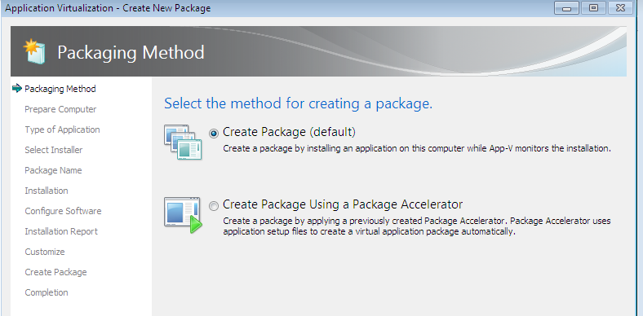

Choose to package a standard application.

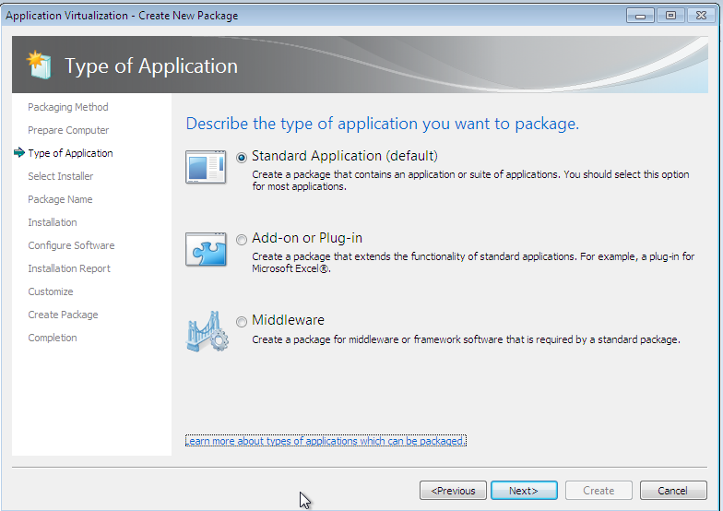

Navigate to your installation files.

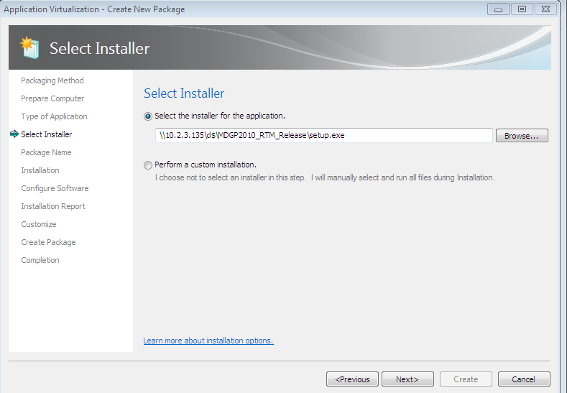

Provide a name for your package and click Next.

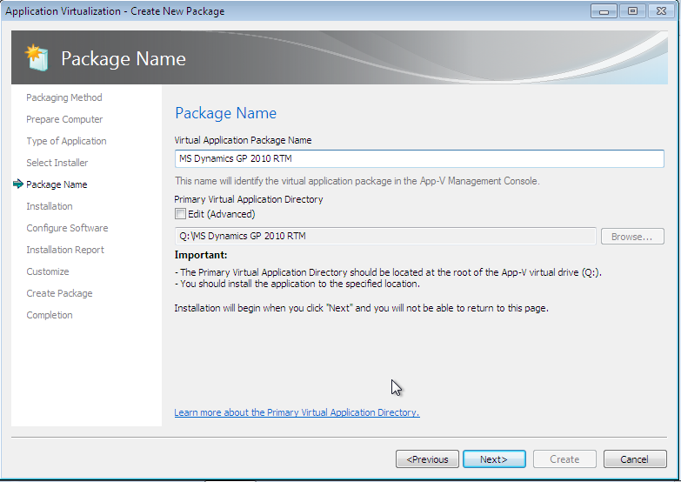

The installation begins with installing Microsoft Dynamics GP pre-requisites.

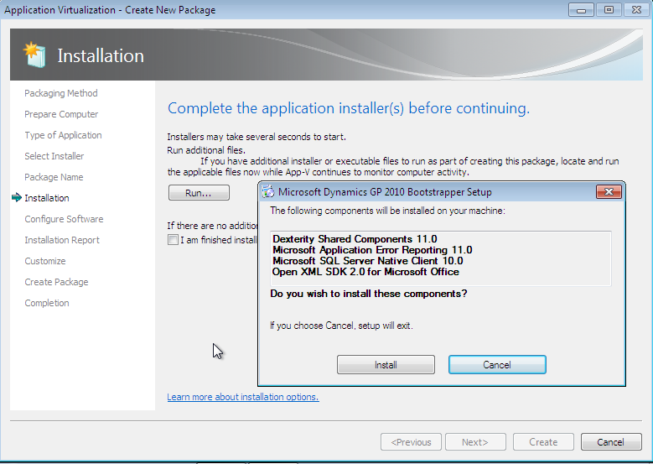

The Microsoft Dynamics GP installation panel opens. Click Microsoft Dynamics GP under Install.

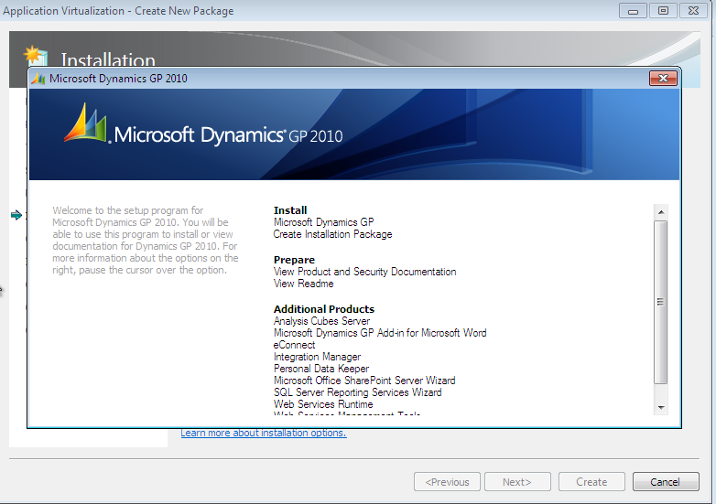

Install Microsoft Dynamics GP features as required.

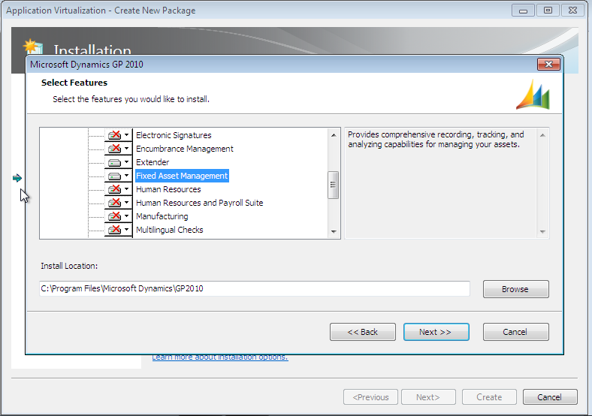

If you plan to use the same image on both 32-bit and 64-bit clients, we recommend using a different install location than the default “Program Files” folder because the 64-bit clients will be expected to be in “Program Files (x86)” folder.

If you want to keep the default location, you will have to sequence on both 32-bit and 64-bit machines, resulting in two packages.

We don’t recommend creating the Data Source to your SQL server as part of the sequencing process. Otherwise, you will need to update your App-V image if the server configuration is updated as the DSN information will be embedded in the image.

Follow the instructions until the Microsoft Dynamics GP installation completes.

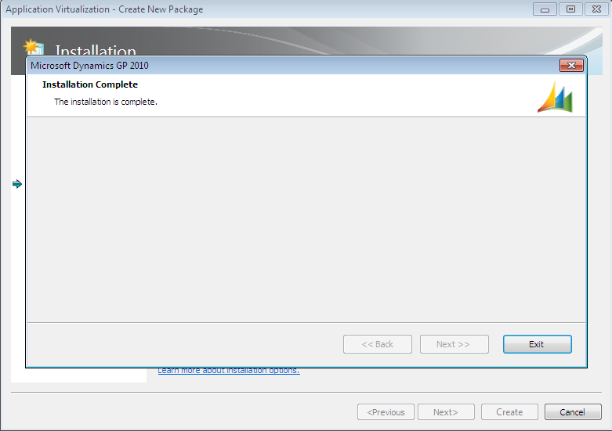

Then, mark the “I am finished installing” option and click Next.

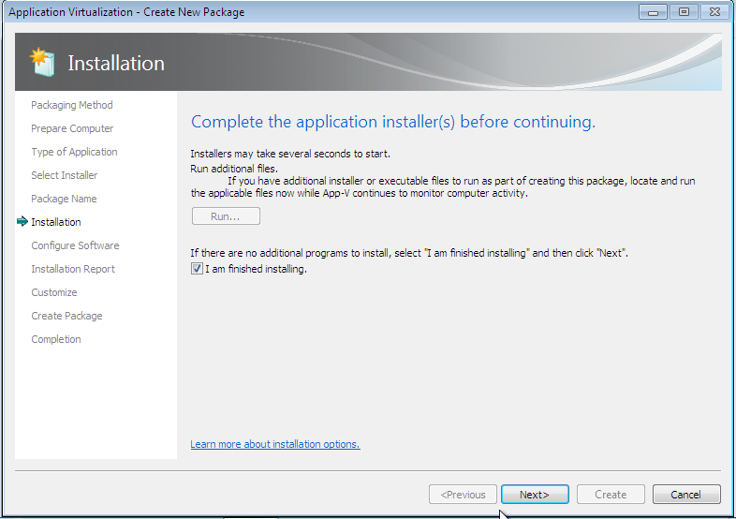

The system changes are collected.

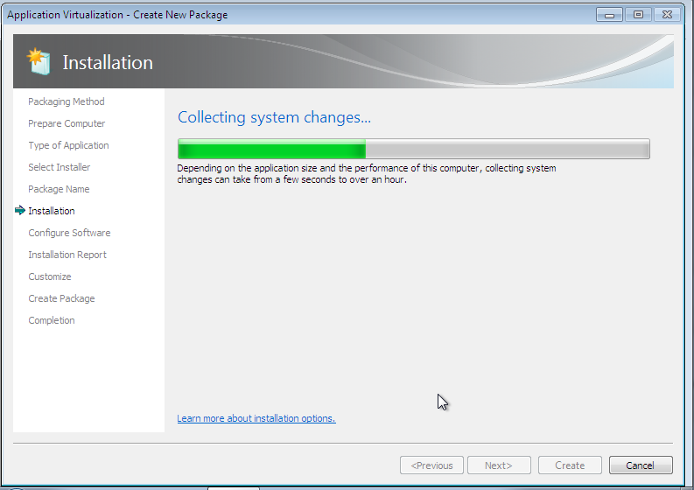

Even though you clicked Finished, the sequencer is still monitoring the changes to the system at this point. We recommend starting Microsoft Dynamics GP Utilities from the panel below in order to complete the Microsoft Dynamics GP client configuration. This sets up the image’s Dex.ini file and also synchronizes the client with the account framework.

Note: The Microsoft Dynamics GP databases need to either already exist or be created during this step in order to complete the GP client configuration. It is recommended that you would have created these databases using a Microsoft Dynamics GP installation on a different machine before sequencing.

Select the GP Utilities application and click on Run Selected.

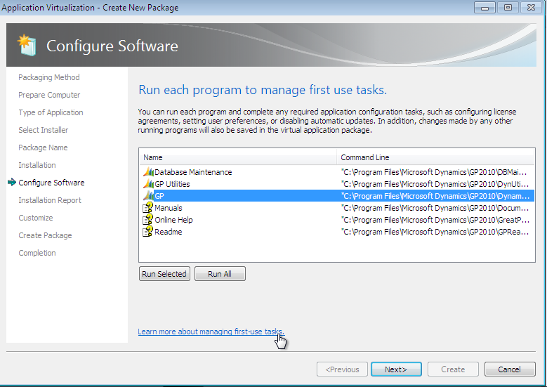

From here you can customize the image.

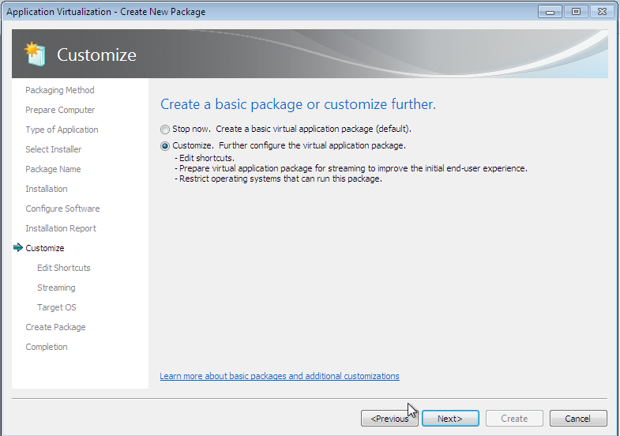

You can remove some of the shortcuts (for instance keeping just GP and GP Utilities).

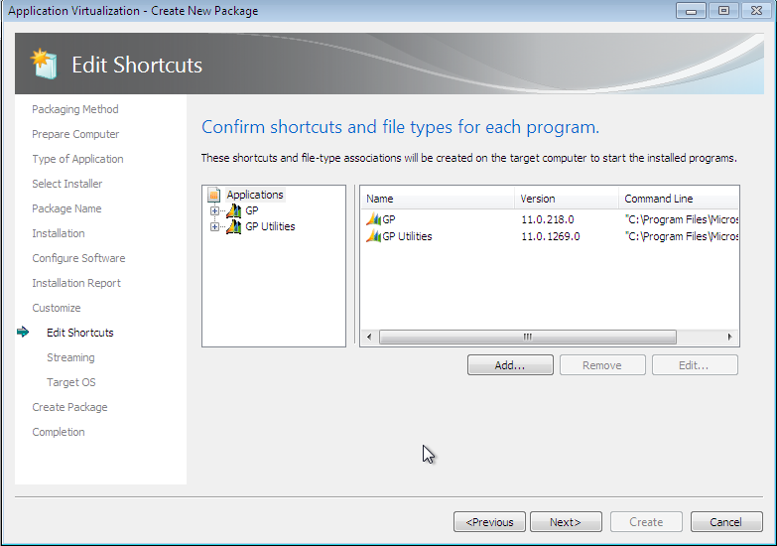
It is recommended you run each program to optimize the package.

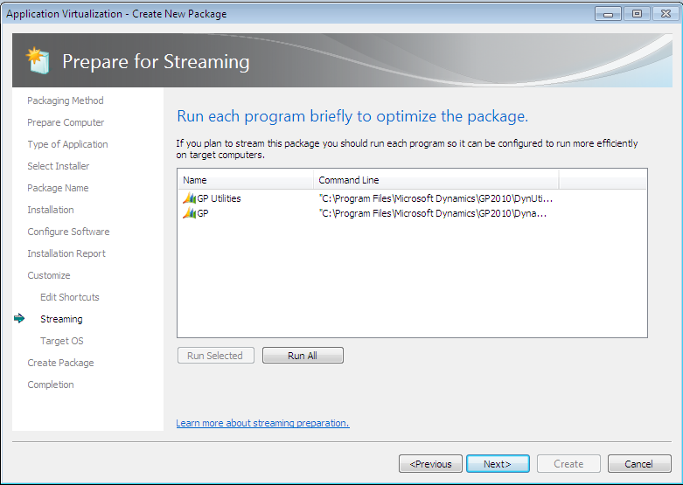

When the programs are run once, check marks appear.

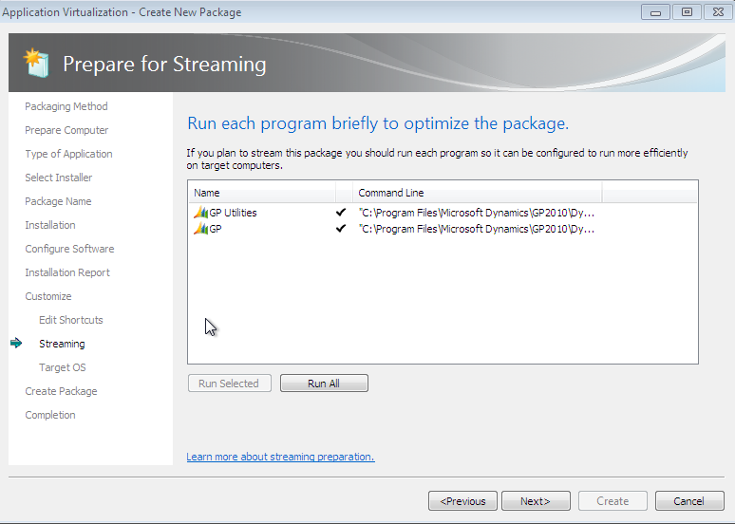

Choose your target operating system. It is recommended to use a version that is equal to or more recent that the operating system of the sequencing machine. In this case since we were sequencing on Windows 7, we selected Windows 7 and Windows 2008 R2 operating systems.

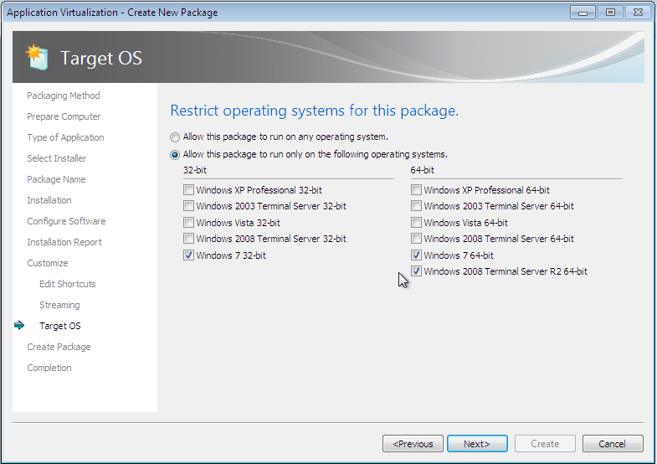

At this point you can either save or continue. Use continue to review the parameters before saving.

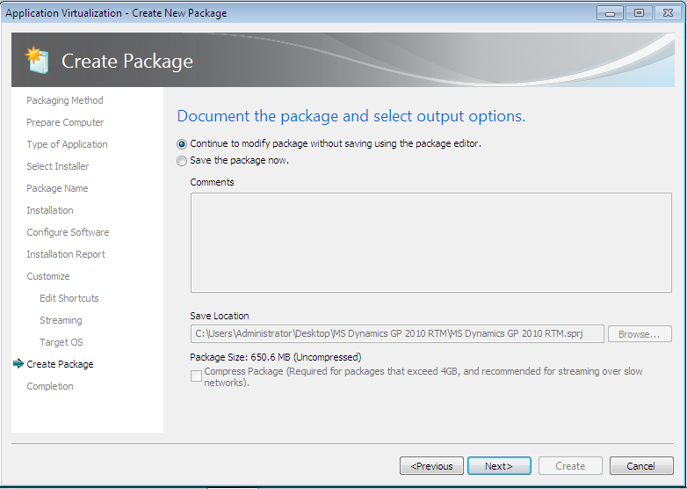

The package is now ready and you can review the different tabs.

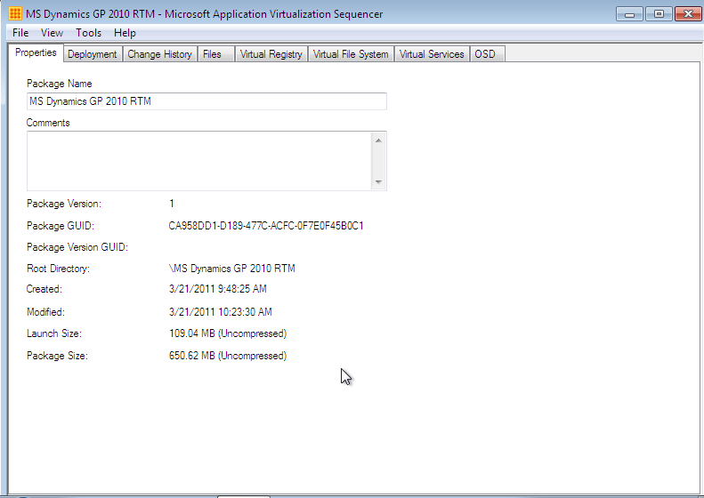

You can now save the sequencer project.

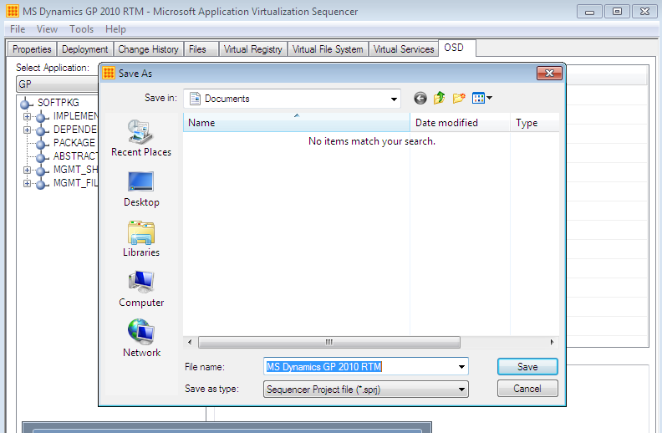

Publishing the sequenced Microsoft Dynamics GP Client

Deploying the packaged files

Now that packaged application is ready, you need to copy the files to a shared directory that is accessible to the App-V streaming server.

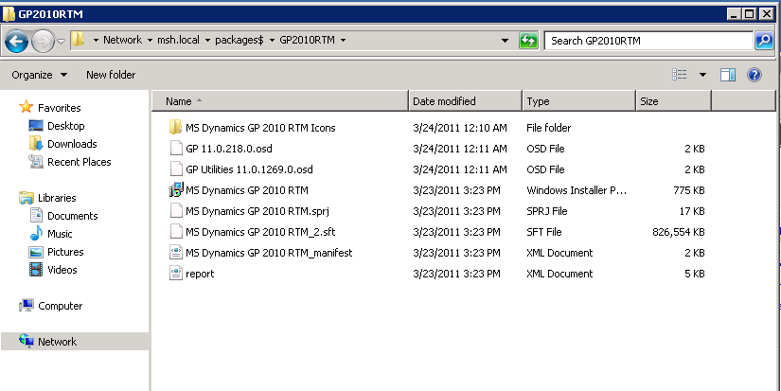

You will need to replace the generic variable placed in the osd file during sequencing with the actual location of the package. In this scenario, the name of the streaming server where the osd file is located is saaapvprd01.msh.local.

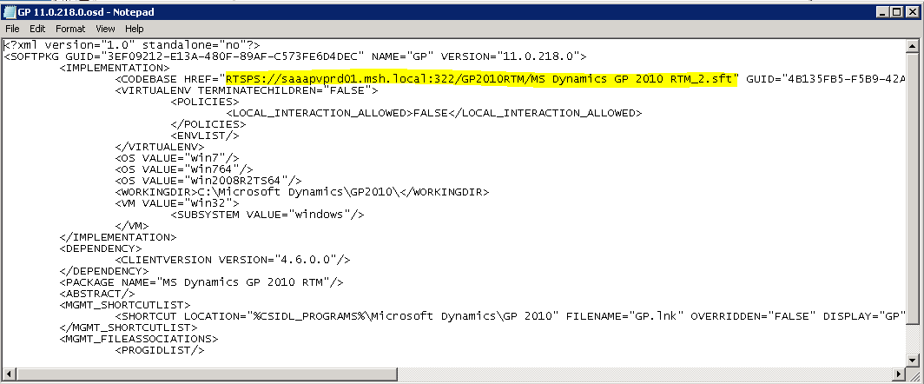

Configure App-V server
Start the App-V management console and click Import Applications.

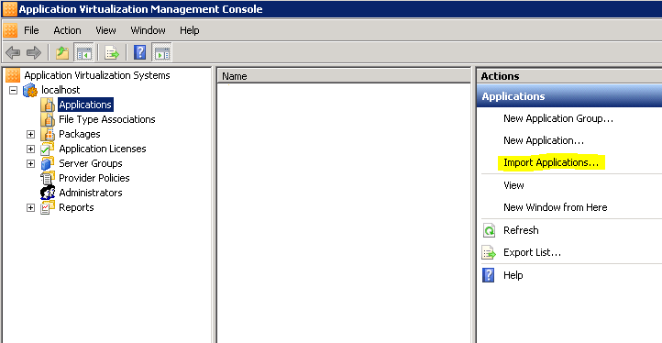

Navigate to the location of the package files and select the project file and click Open.

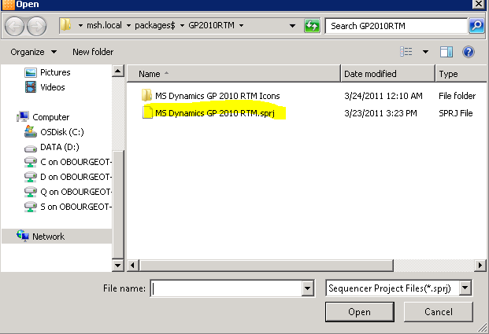

Provide a description and a Server Group (default is Default Server Group).

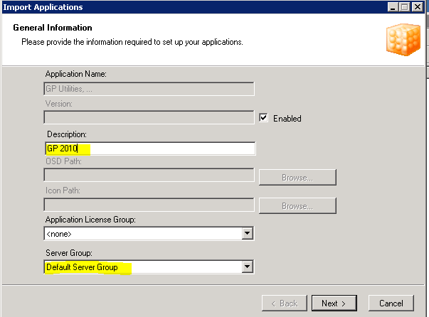

You can decide which way the virtual application will publish itself on the client machine.

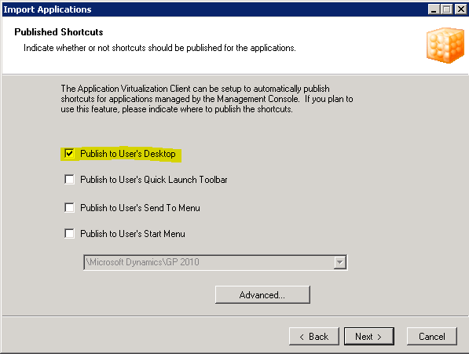

Select the domain group that will have access to Microsoft Dynamics GP.

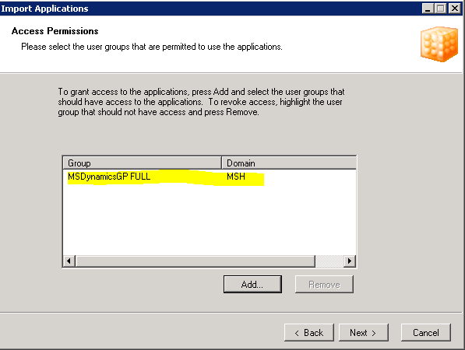

Click Finish.

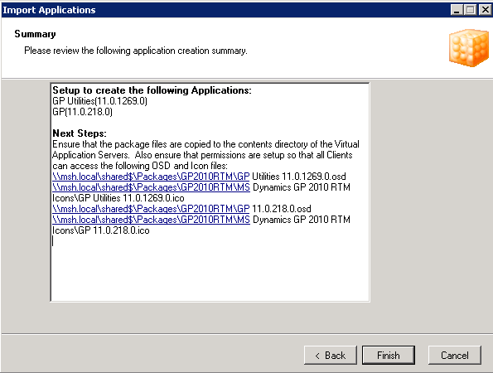

The application now appears in the console.

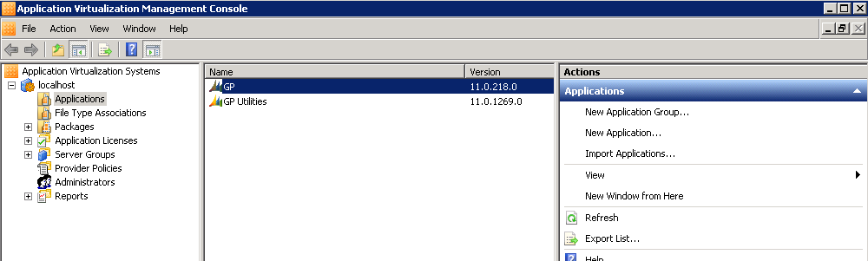

Execute the sequenced Microsoft Dynamics GP Client

On End-user Desktop
The end-user machine needs to have the App-V Client installed and configured with the App-V server as shown below (using your publishing server information).

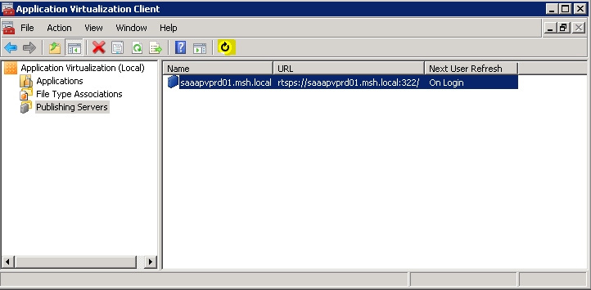

If the user who is logged on is part of the domain group that was selected, the App-V client will list the Microsoft Dynamics GP applications and create the shortcut on the desktop as shown below.

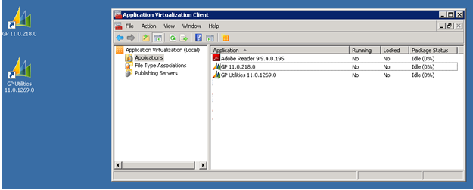

When clicking the GP shortcut, the application will start loading as shown below:

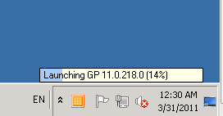

Depending on the network, loading the application can take some time. After the application is loaded once, it will remain cached on the machine. It won’t be reloaded unless the package is updated on the server.

Microsoft Dynamics GP Client is now running on the user’s desktop.

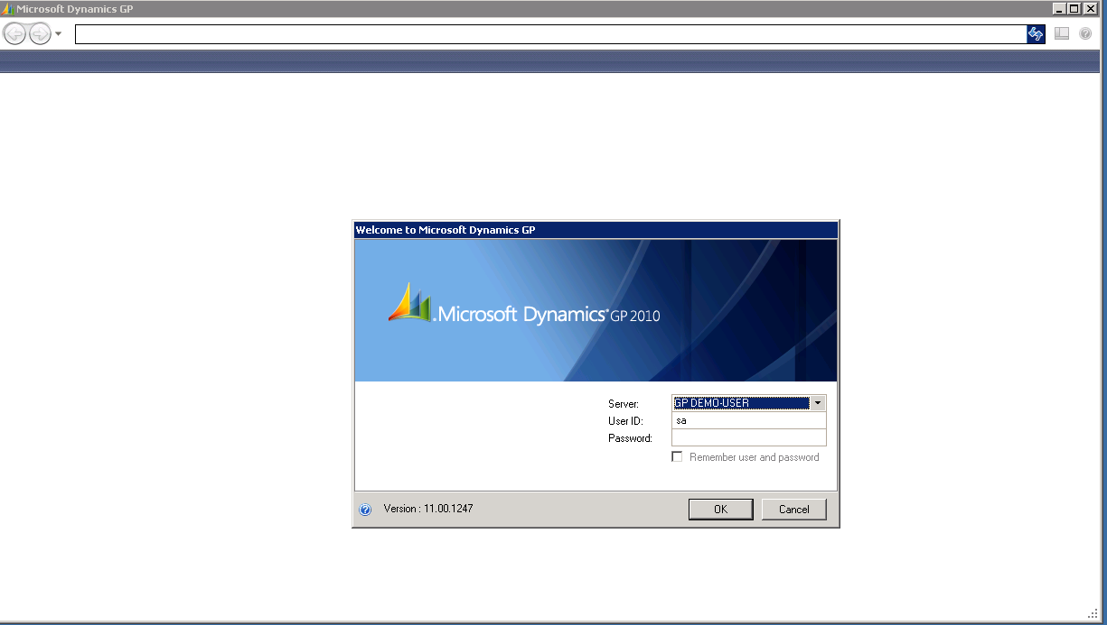

On Remote Desktop Services
The Remote Desktop Services machine needs to also have the App-V Client installed and configured with the App-V server.

The process is very similar as the one for the desktop unless you are using a RemoteApps solution where only specific applications are published and not the entire desktop. In this case, you need to configure RemoteApps using the command line App-V syntax:

"C:\Program Files (x86)\Microsoft Application Virtualization Client\sfttray.exe" /launch "GP 11.0.218.0"

Also, you may want to pre-load the package on the Remote Desktop Services server(s) to avoid having the first user executing the application wait for the initial load. Note that if you deploy separate Microsoft Dynamics GP instances, you will have to repeat this step for each instance.

"C:\Program Files (x86)\Microsoft Application Virtualization Client\sfttray.exe" /load "GP 11.0.218.0"

Updating the sequenced client
The application package can be updated using the sequencer. Choose to update the application in an existing package option.

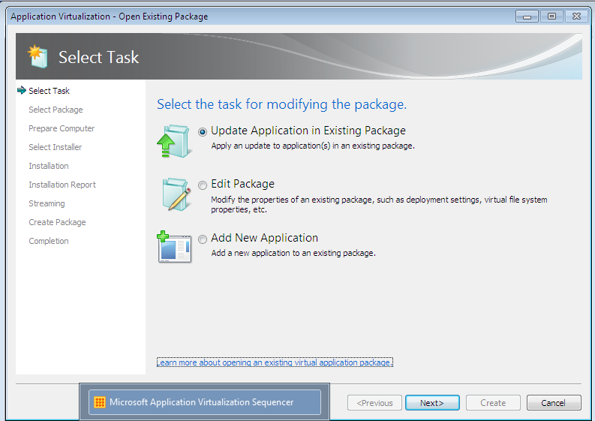

Navigate to the project file that was created earlier.

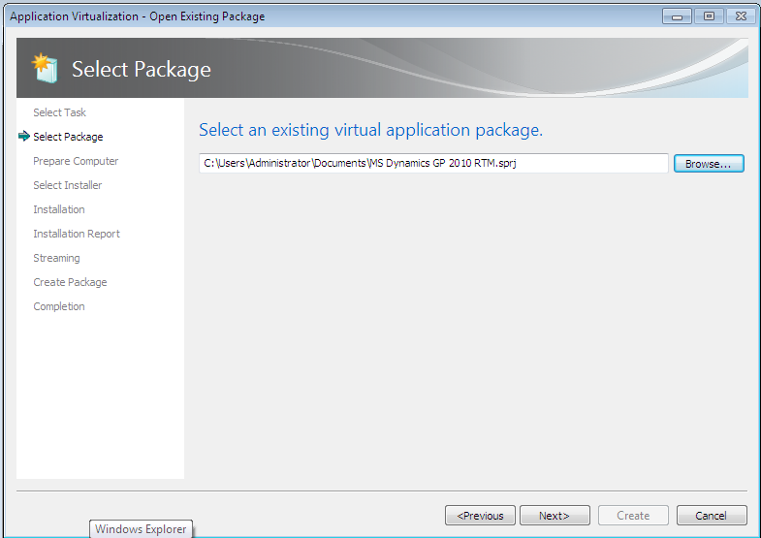

You can now either run the Microsoft Dynamics GP installer again (to add a new GP feature for instance) or perform a customer installation (importing a forms and reports customization package or dropping a cnk file). You can also run a Windows Installer patch file (.msp file) here, which is how service packs are distributed.

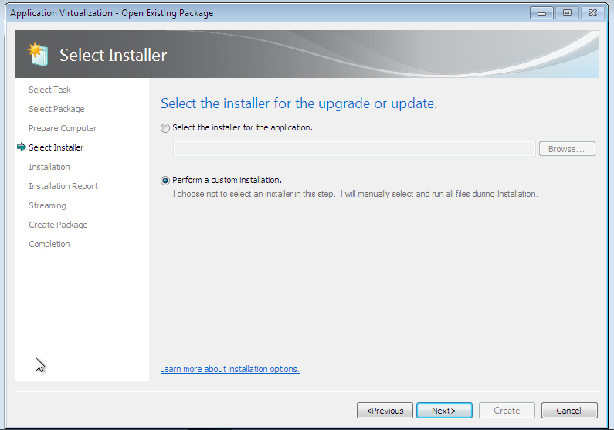

In either scenario, once you are done updating Microsoft Dynamics GP, you can click the “I am finished installing” option and the sequencer will update the project file.

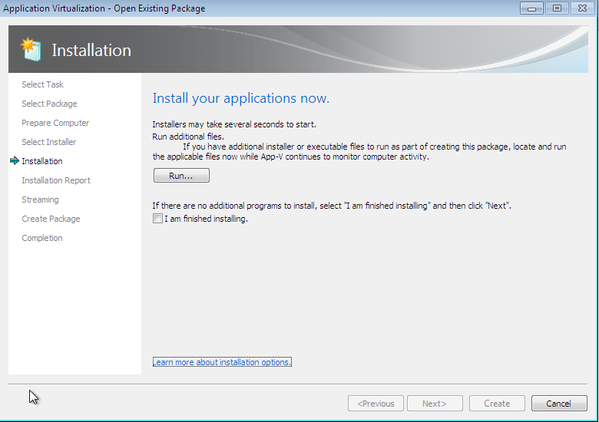

You will notice that the sequencer keeps a version history of the sequencing step and will add the version number at the end of the .sft file.

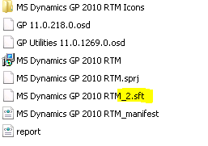

You can now add a new version of the package on the streaming server:

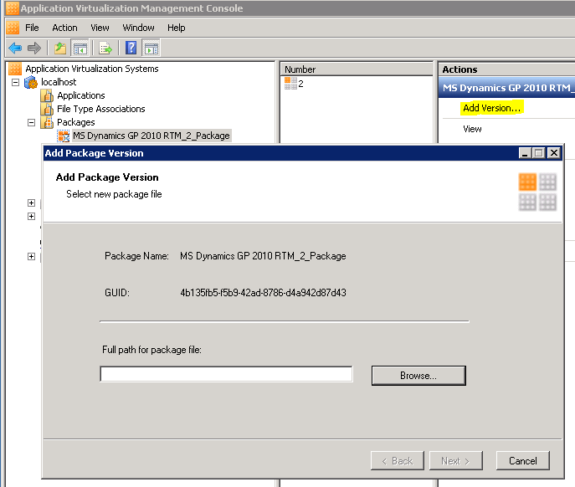

Browse to your project file and the package will be updated. The application settings (shortcuts, access permissions, and so on) will remain the same and only the package is updated.
One thing to be aware of is that upgrades of a package will not occur until all users of a package have closed all associated applications.

References

General guideline available in the App-V Sequencing Guide: http://download.microsoft.com/download/F/7/8/F784A197-73BE-48FF-83DA-4102C05A6D44/App-V/App-V%204.6%20Service%20Pack%201%20Sequencing%20Guide.docx

TS-specific advice in the App-V RDS whitepaper: http://download.microsoft.com/download/2/5/E/25EEFF4E-A81A-464F-9AB1-98FA1EF755AA/App-V%20Remote%20Desktop%20Services.docx

Microsoft Desktop Optimization Pack
http://www.microsoft.com/windows/enterprise/default.aspx

Microsoft Application Virtualization for Terminal Services
http://www.microsoft.com/systemcenter/appv/terminalsvcs.mspx

MSDN
http://www.microsoft.com/msdn

Application Virtualization Troubleshooting and Support
http://technet.microsoft.com/en-us/appvirtualization/bb676740.aspx

About Microsoft Dynamics

Microsoft Dynamics is a line of integrated, adaptable business management solutions that enables you and your people to make business decisions with greater confidence.

Microsoft Dynamics works like and with familiar Microsoft software such as Microsoft Office, which means less of a learning curve for your people, so they can get up and running quickly and focus on what’s most important. Built to work with Microsoft technologies, it works easily with the systems your company already has implemented. By automating and streamlining financial, customer relationship, and supply chain processes, Microsoft Dynamics brings together people, processes, and technologies, helping increasing the productivity and effectiveness of your business, and helping you drive business success.

U.S. and Canada Toll Free (888) 477-7989
Worldwide (1) (701) 281-6500
www.microsoft.com/dynamics
This document is provided “as-is.” Information and views expressed in this document, including URL and other Internet Web site references, may change without notice. You bear the risk of using it.
Some examples depicted herein are provided for illustration only and are fictitious. No real association or connection is intended or should be inferred.
This document does not provide you with any legal rights to any intellectual property in any Microsoft product. You may copy and use this document for your internal, reference purposes. This document is confidential and proprietary to Microsoft. It is disclosed and can be used only pursuant to a non-disclosure agreement.
© 2011 Microsoft Corporation. All rights reserved.
Microsoft, Microsoft Dynamics, the Microsoft Dynamics logo, Active Directory, MSDN, Windows, Windows Server, and SQL Server are trademarks of the Microsoft group of companies.

